**Exercise**

* **printing multiplication table for any number, from any number to any number (all given in input) (Forward and reverse order multiplication should be implemented in the program)**

**Approach:**

**So here we did like this**

**Forward : Run a incrementing for loop from Start to end and print the value of the given number what you want to get a multiplication table (note: Start < End )**

**Reverse : Run a decrementing for loop from Start to end and print the value of the given number what you want to get a multiplication table**

**(note: Start > End )**

**Solution 👇**

**Java :**

**import java.util.Scanner;**

**public class CodeXam**

**{**

**public static void main(String[] args)**

**{**

**Scanner s = new Scanner(System.in);**

**System.out.print(" Enter the number you want to get a multiplication table of : ");**

**int n=s.nextInt();**

**System.out.print("From where : ");**

**int start=s.nextInt();**

**System.out.print("To where : ");**

**int end=s.nextInt();**

**if (start <= end )**

**for(int i=start; i <= end; i++)**

**{**

**System.out.println(n+" * "+i+" = "+n*i);**

**}**

**else{**

**for(int i=start; i >=  end; i--){**

**System.out.println(n+" * "+i+" = "+n*i);**

**}**

**}**

**}**

**}**

**output:**

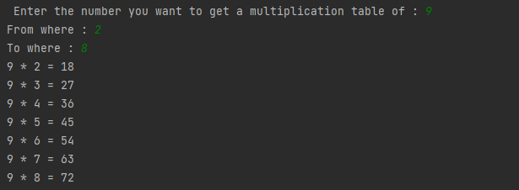

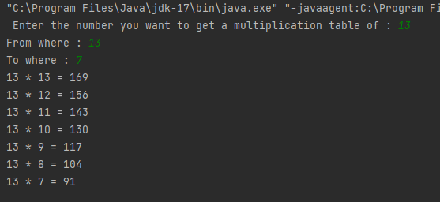

**Python :**

**value = int(input("Enter the number you want to get a multiplication table of : "))**

**start = int(input("From where : "))**

**end = int(input("To where : "))**

**if start <= end:**

**for i in range(start, end+1):**

**print(f"{value} * {i} = {value * i}")**

**elif start > end:**

**for o in range(start, end-1, -1):**

**print(f"{value} * {o} = {value * o}")**

**output:**

